Experiment No. 6
K-Means and Hierarchical Clustering
Name : Rishabh Ramani
Class : D15B
Roll No : 48
Batch : B

PART A: K-MEANS CLUSTERING

Code
from sklearn.datasets import make_blobs
X1, y1 = make_blobs(n_samples=300, n_features=2, centers=4, cluster_std=0.60, random_state=0)
X2, y2 = make_blobs(n_samples=300, n_features=3, centers=3, cluster_std=[0.5, 1.0, 0.7], random_state=42)

sse = []
for i in range(1, 11):
kmeans = KMeans(n_clusters=i, random_state=42, n_init='auto')
kmeans.fit(X1)
sse.append(kmeans.inertia_)
plt.plot(range(1, 11), sse, marker='o')
plt.title('Elbow Method for K-Means on X1')
plt.show()

k_optimal = 4
kmeans = KMeans(n_clusters=k_optimal, random_state=42, n_init='auto')
kmeans.fit(X1)
kmeans_labels = kmeans.labels_

plt.scatter(X1[:, 0], X1[:, 1], c=kmeans_labels, s=50, cmap='viridis', alpha=0.8)
plt.scatter(kmeans.cluster_centers_[:, 0], kmeans.cluster_centers_[:, 1], s=200, c='red', marker='X')
plt.title('K-Means Clustering on X1 Dataset')
plt.show()

Dataset Source (K-Means)
Dataset Name: Mall Customer Segmentation Dataset
Source: https://www.kaggle.com/datasets/vjchoudhary7/customer-segmentation-tutorial-in-python

Dataset Description
This dataset contains customer information from a shopping mall and is used for segmentation analysis.
- Total Records: 200
- Total Features: 5
- Problem Type: Unsupervised Clustering

Feature | Description
CustomerID | Unique ID
Gender | Male/Female
Age | Customer age
Annual Income (k$) | Yearly income
Spending Score (1-100) | Spending behavior score

For clustering, typically used features: Annual Income and Spending Score.

Mathematical Formulation of K-Means
K-Means aims to partition data into K clusters by minimizing intra-cluster variance.
Objective Function:
J = Σᵢ Σ(x∈Cᵢ) ||x - μᵢ||²
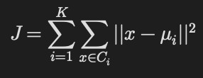
Where: Cᵢ = cluster, μᵢ = centroid, ||x - μᵢ||² = Euclidean distance

Algorithm Limitations
- Need to specify K manually
- Sensitive to initial centroid selection
- Works only for spherical clusters
- Affected by outliers
- Not suitable for non-globular cluster shapes

Methodology / Workflow
Dataset → Feature Selection → Scaling → Elbow Method → K-Means Training → Cluster Visualization

Performance Analysis
Evaluation Metrics Used:
- Inertia (Within Cluster Sum of Squares)
- Silhouette Score
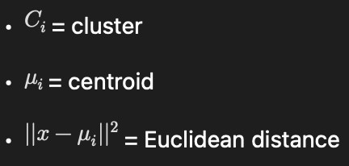
Silhouette Score Range: -1 to 1. Higher value → better cluster separation.

Hyperparameter Tuning
Parameter tuned: Number of clusters (K)
Method used: Elbow Method and Silhouette Score Optimization

Output - Elbow Method & K-Means Clustering:
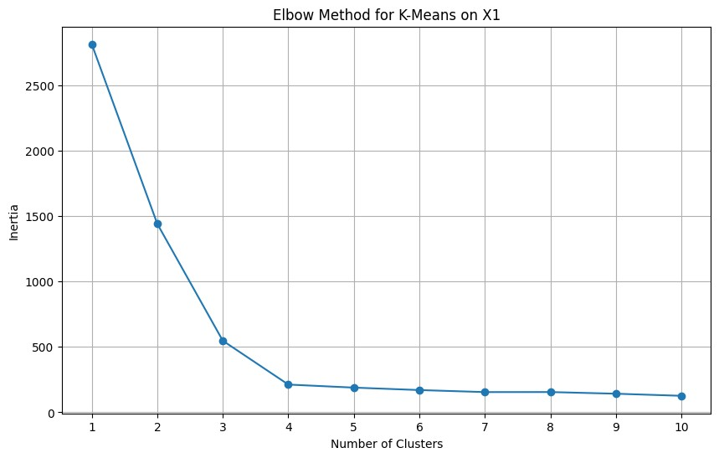
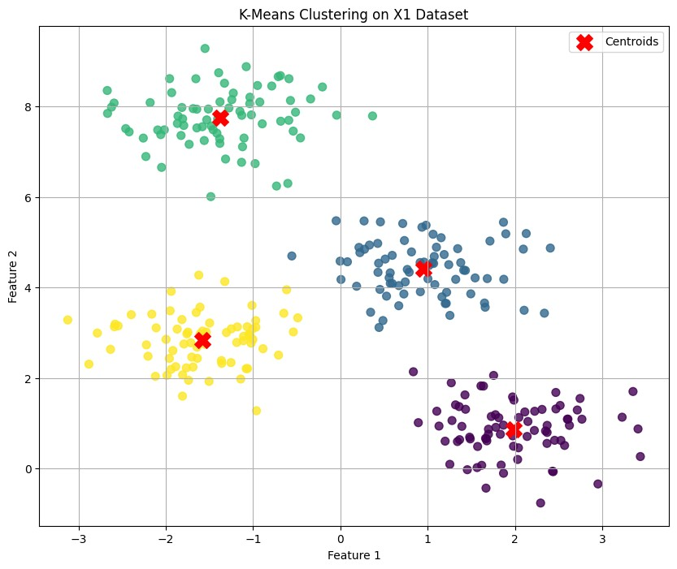

PART B: HIERARCHICAL CLUSTERING

Code
from scipy.cluster.hierarchy import linkage, dendrogram
Z = linkage(X2, method='ward')
plt.title('Hierarchical Clustering Dendrogram for X2')
dendrogram(Z, truncate_mode='lastp', p=12, show_leaf_counts=True, leaf_rotation=90., leaf_font_size=12., show_contracted=True)
plt.show()

hc_optimal_clusters = 3
hc = AgglomerativeClustering(n_clusters=hc_optimal_clusters, linkage='ward')
hc_labels = hc.fit_predict(X2)
ax.scatter(X2[:, 0], X2[:, 1], X2[:, 2], c=hc_labels, s=50, cmap='viridis', alpha=0.8)
ax.set_title('Hierarchical Clustering on X2 Dataset (3D)')
plt.show()

Dataset Source (Hierarchical)
Dataset Name: Wholesale Customers Dataset
This dataset contains annual spending amounts for customers in different product categories.
- Total Records: 440
- Features: 8
- Type: Unsupervised Learning

Feature | Description
Fresh | Annual spending on fresh products
Milk | Spending on milk
Grocery | Grocery spending
Frozen | Frozen products
Detergents_Paper | Cleaning products
Delicassen | Delicacy items

Mathematical Formulation of Hierarchical Clustering
Hierarchical clustering builds nested clusters using linkage criteria.
Common Linkage Methods:
- Single Linkage: D(A,B) = min d(a,b)
- Complete Linkage: D(A,B) = max d(a,b)
- Average Linkage: D(A,B) = (1/|A||B|) Σ d(a,b)

Algorithm Limitations
- Computationally expensive for large datasets
- Difficult to decide number of clusters
- Sensitive to noise and outliers
- Cannot undo previous merges

Methodology / Workflow
Dataset → Scaling → Distance Matrix → Agglomerative Clustering → Dendrogram → Cluster Assignment

Performance Analysis
Evaluation Methods:
- Dendrogram visualization
- Silhouette Score
- Cluster compactness
Hierarchical clustering provides better interpretability via dendrograms.

Hyperparameter Tuning
Parameters tuned: Number of clusters, Linkage method (single, complete, average, ward)
Ward linkage often provides better compact clusters.

Output - Dendrogram & 3D Clustering:
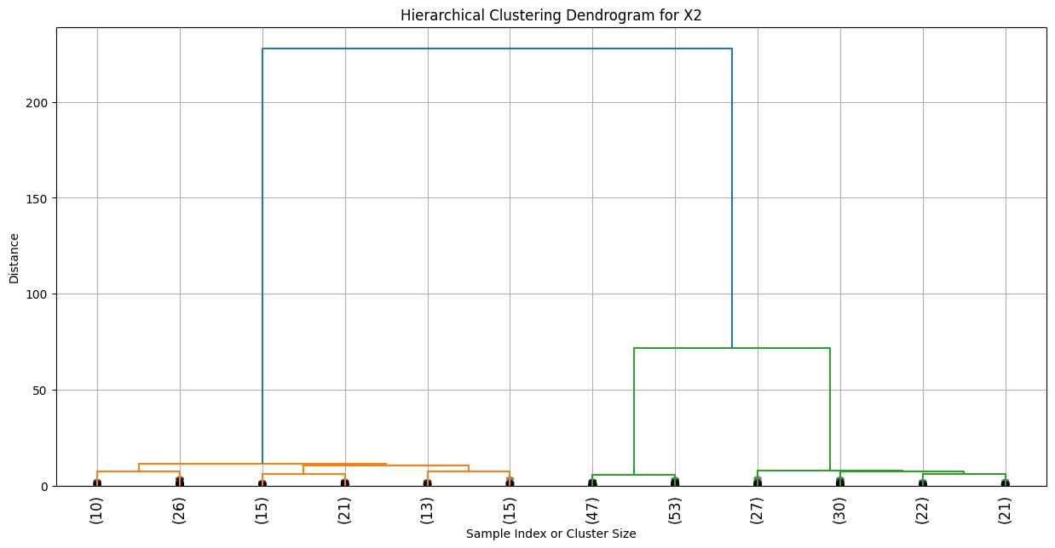
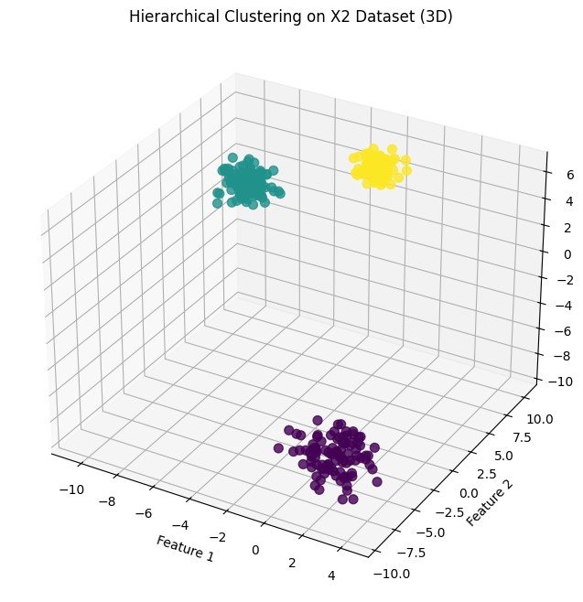

Final Comparative Analysis
Aspect | K-Means | Hierarchical
Need K beforehand | Yes | No
Speed | Fast | Slower
Visualization | Cluster Plot | Dendrogram
Suitable for | Large datasets | Smaller datasets
Interpretability | Moderate | High

Final Conclusion
- K-Means is efficient for large datasets and works well for spherical clusters.
- Hierarchical clustering provides deeper structural insight through dendrograms.
- Feature scaling is essential in both methods.
- Choice of clustering method depends on dataset structure and size.

